**Programming - Lab Sheet 01 - B24**Name:U.L.M.Aasik  
**Submission Date:**08.02.2025

**Tasks  
1.  
(Pseudocode)  
START  
INPUT: number1,number2,number3  
IF number1> number2 and number1>number3 THEN  
 PRINT(“Laegest number is number1”)  
ELSE IF number2> number1 and number2>number3 THEN  
PRINT(“Largest number is number2”)  
ELSE  
PRINT(“Largest number is number3”)  
END IF  
END  
  
Flowchart: 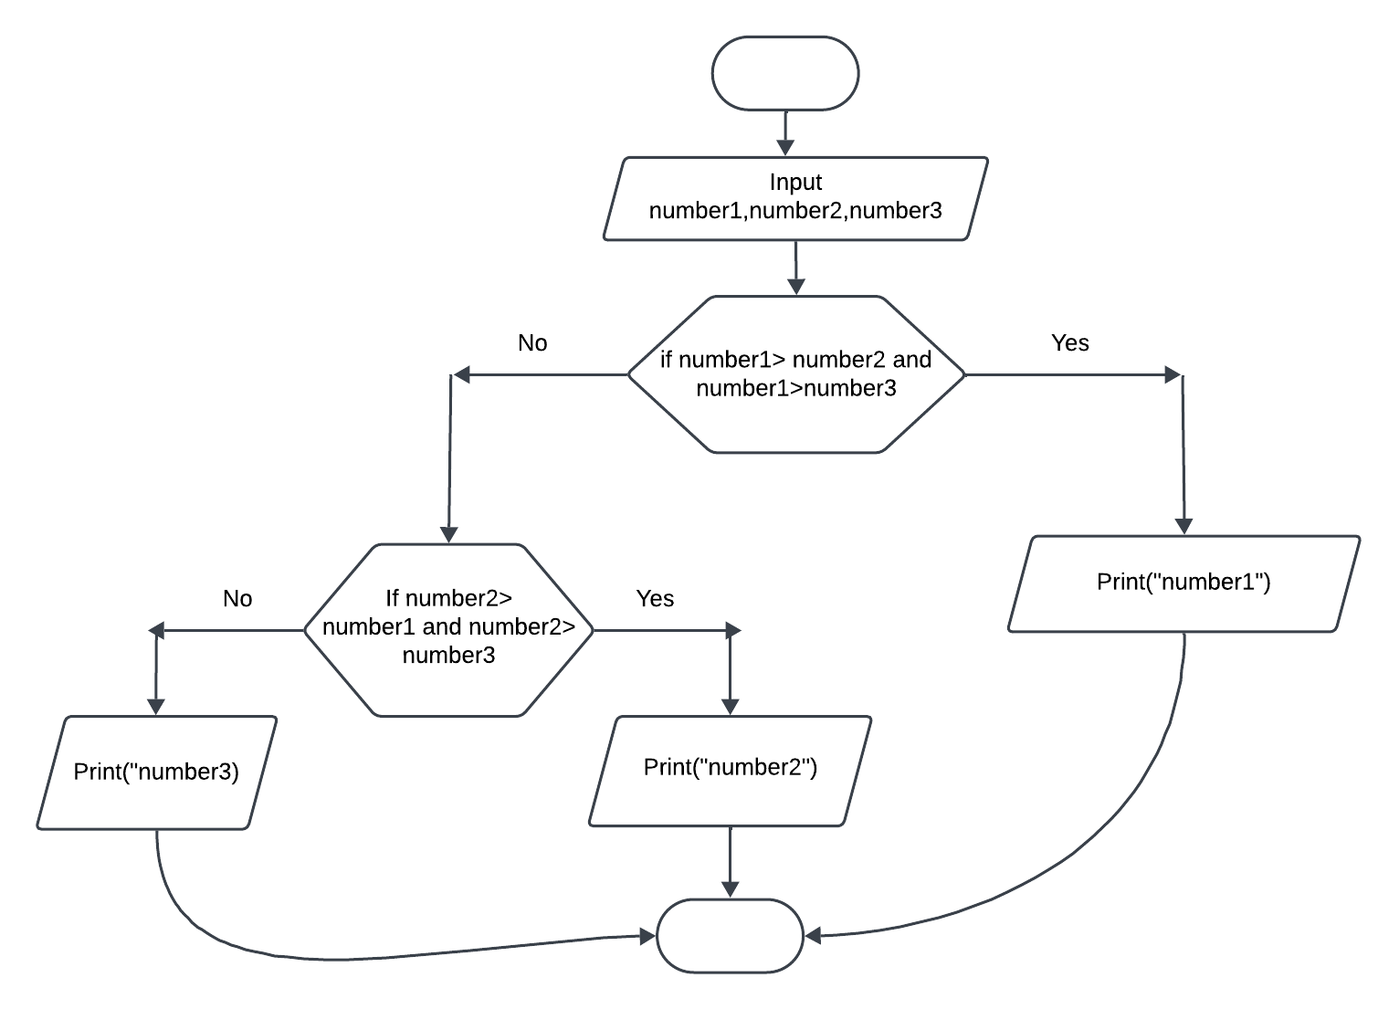  
  
2. Pseudocode:**

**Start**

**Input a number: n**

**Initialize factorial = 1**

**For i from 1 to n:  
 factorial = factorial * i**

**Print("Factorial of n is factorial")**

**End  
  
3. Pseudocode:**

**1. Start**

**2. Input a number: n**

**3. If n <= 1:**

**Print ("Not a prime number")**

**Else:**

**Initialize is_prime = True**

**For i from 2 to sqrt(n):**

**If n % i == 0:**

**is_prime = False**

**Break**

**If is_prime:**

**Print ("Prime number")**

**Else:**

**Print ("Not a prime number")  
4. End**

**4. Pseudocode:**

**1. Start**

**2. Input hourly pay rate: rate**

**3. Input hours worked: hours**

**4. If hours <= 40:**

**regular_pay = hours * rate**

**overtime_pay = 0**

**Else:**

**regular_pay = 40 * rate**

**overtime_pay = (hours - 40) * rate * 1.5**

**5. gross_pay = regular_pay + overtime_pay**

**6. Print ("Gross pay is gross_pay")**

**7. End  
  
5. Flowchart:  
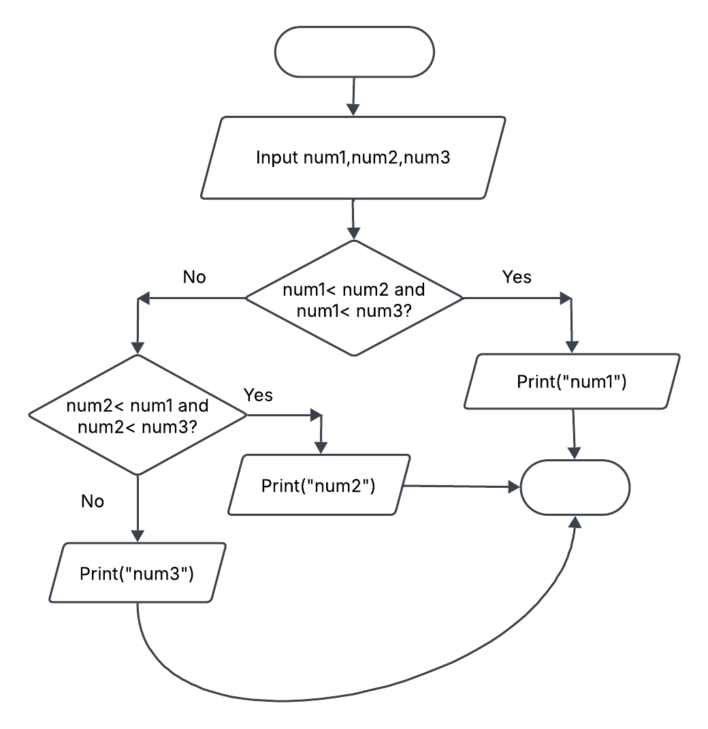**

**6. Flowchart  
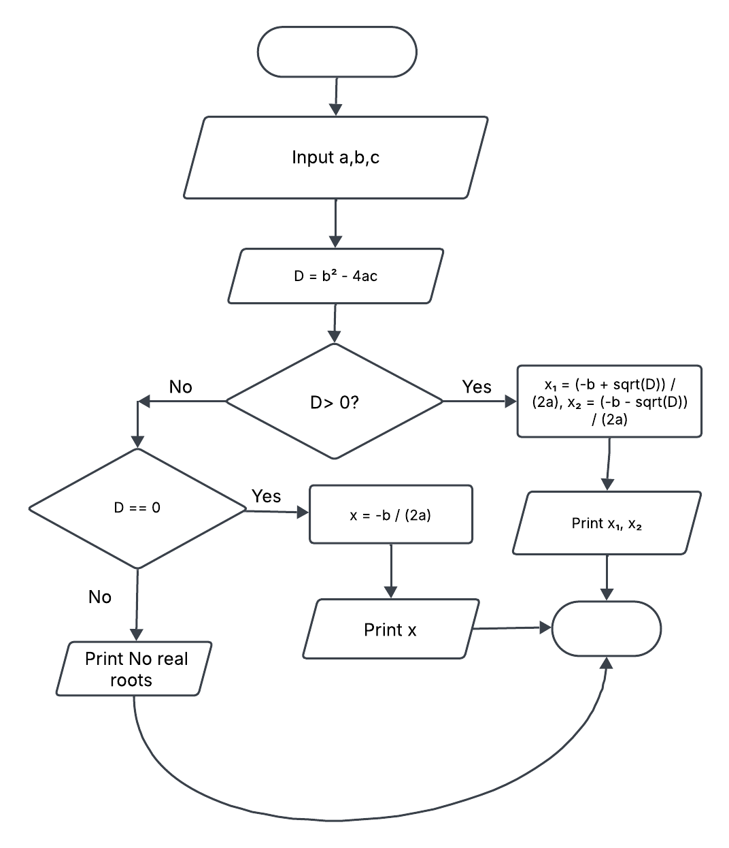**

7.  
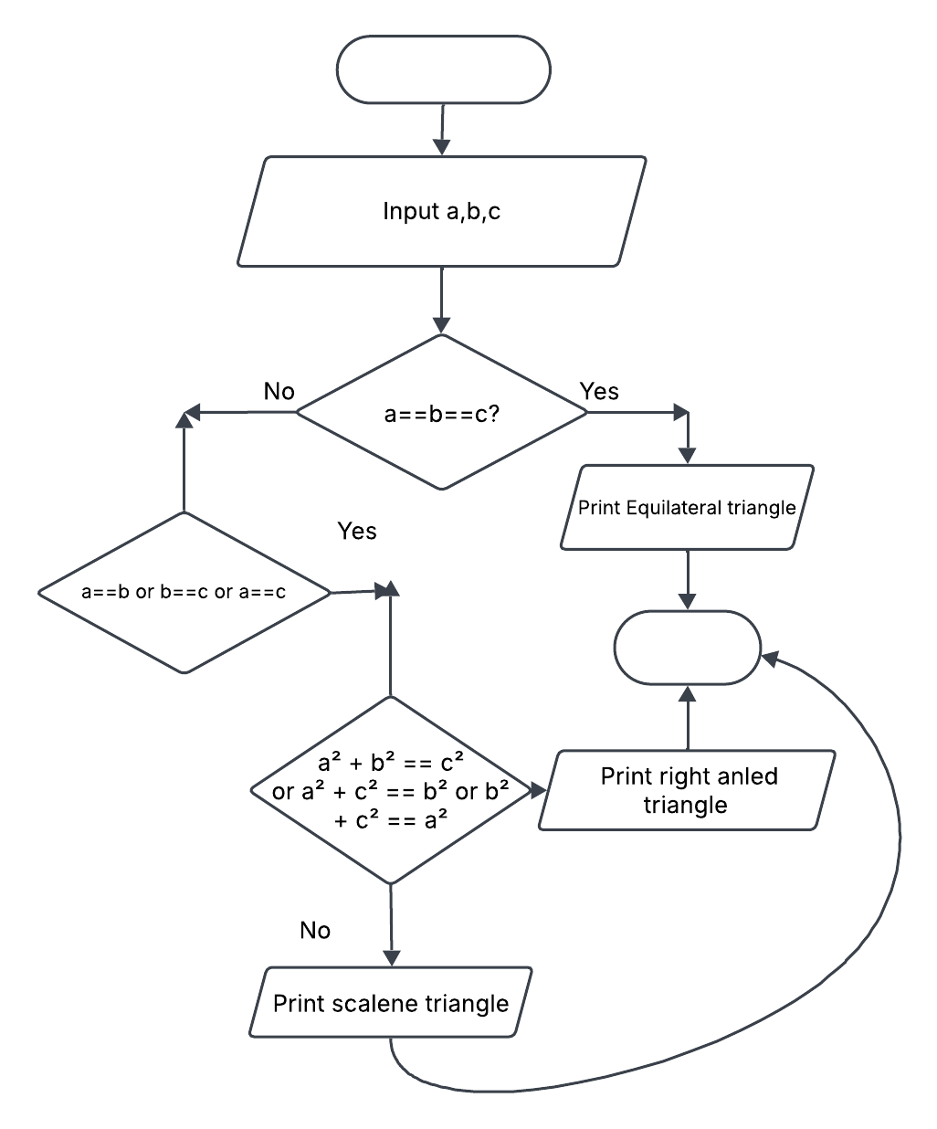

8. Pseudocode:  
  
1. Start

2. Input year: y

3. If (y % 4 == 0 and y % 100 != 0) or (y % 400 == 0):

Print "Leap year"

Else:

Print "Not a leap year"

4. End